**The empirical research of the effect of a product packaging adaptation giving to the buying intention of overseas consumers.**

Nihon University College of Law

Usui Seminar 8th

TEAM DESIGN

Daisuke IKITO

Mayu SAKURAI

Taiga SUDO

Kana TAGUCHI

Mayu YAMADA

Daisuke IKITO (Team Leader)

<TEL:080-3477-8632>

Email:dikihouse@gmail.com

**The empirical research of the effect of a product packaging adaptation giving to the buying intention of overseas consumers.**

**Abstract**

This study is explorative study. This study aims to reinforce competitiveness of the company in Japan which handles convenience goods in foreign countries. As an exclusive step, we pay attention to a product packaging and study it. Packaging must serve as a silent salesperson and attract the shopper's attention. However, it is no proof whether Japanese product packaging is effective or not in overseas. Moreover, it is not organized as data from business point of view. Therefore, we prove whether Japanese product packaging is a means to strengthen company competitiveness across borders and investigated the effect of product packaging giving buying intention to consumers through original consumer experiment. From the consumer investigation, we found effect of product packaging giving consumer buying intention was different by countries. Therefore, we propose a packaging adaptation model from consumer investigation and firm interview.

keywords: product packaging, consumer’s buying intention, product packaging adaptation model

**Table of Contents**

Abstract

1. Background

1.1Global Expansion

1.1.1 Declining Population

1.1.2 Commoditization in Market

1.1.3 Status of Global Expansion of Japanese Companies

1.2 Buying Intention and Product Packaging

1.3 Research Objectives

1.3.1 Objective 1

1.3.2 Objective 2

2. Literature Review

2.1 Definition of Package Design

2.2 Previous Study of Product Packaging

2.3 The Effect that Product Packaging gives to Consumer’s Buying Behavior

2.4 Japanese High Level of Packaging Technology

2.5 Case Review

3. Methodology

3.1 Explorative Case Study on Product Packaging across Borders of 9 firms

3.2 Sample Selection

3.3 Results of Investigation

3.3.1 Product Packaging’s Definition of our Study

3.4 A Flow Our Study

3.5 Experimental Investigation to Consumers

3.5.1 Packaging Selection

3.5.2 Country Selection

3.5.3 Sample and Data Collection

3.5.4 Procedure

4 Result and Discussion

4.1 Findings from Experimental Investigation to Consumers

4.2 Findings from Open-ended Question

4.3 Group Interview

4.3.1 Result of Group Interview

4.3.2 Findings from Group Interview

4.4 The Secondly Case Study on Local Appropriative Adaptation of Product Packaging across Borders of 15 firms

4.4.1 Result of Investigation

4.4.2 Findings from Secondly Case Studies

4.5 The Proposal of Effective Use of Product Packaging Model

5. Conclusion

**1.Background**

**1.1 Global Expansion**

In recent years, the number of Japanese firms selling convenience goods which encourage overseas expansion is rising because of commoditization in market and domestic market shrinkage due to the declining population. One of the most important things for a company is to boost profit margin on overseas sales. In this section, we refer to the current status of Japanese market by looking at previous research.

**1.1.1 Declining population**

According to the 2014 population census by Cabinet Office, Japan’s population in 2060 is expected to decrease by two thirds of the current population, that is, approximately 87 million.

Therefore, consumption demand decrease year by year and market growth is not expected. In the long run, declining population shrinks market.

Fig.1 Projection of Population

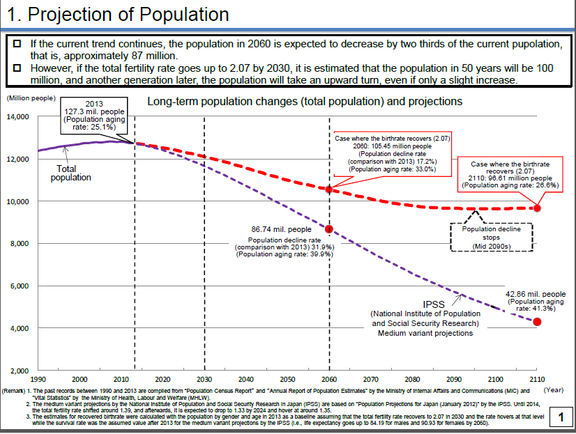

Note. 2014 population census by Cabinet Office

**1.1.2 Commoditization in　Market**

According to the previous research by scholars majoring in marketing, most products and services in today’s market have been transformed for commoditizing, and it is becoming more difficult for firms to invent innovative products than before. For example, packaged consumer products section such as foods and beverages, industrial goods section such as jet engines and inverters, and even service section such as logistics and consulting firms may be considered as commoditized markets (Onzo 2007). Ogawa (2011) defines that commoditization is to fall into the market which has no difference except for the price among rival goods/services or in which there are almost same goods/services for consumers. Consumers tend to make a purchase depending on the price, if a market is commoditized. Furthermore commoditization caused a high possibility of getting involved in a price war, which impacts on a firm's profitability (Ikeo et al. 2010).

1.1.3 Status of global expansion of Japanese companies

According to the 2014 Survey of Overseas Business Activities (published by the Ministry of Economy, Trade and Industry), the number of overseas affiliates of Japanese companies selling convenience goods have been increased year by year.

Table1.Changes of number of overseas affiliates in Japan



Note. 2014 Survey of Overseas Business Activities published by Ministry of Economy, Trade and Industry

The reason why firms are expanding their business across borders year by year is domestic market shrinkage due to the declining population and commoditization in market.

**1.2 Buying Intention and Product packaging**

It is needless to say that what company boost profit margin on sales is to let customer buy a product. From the perspective of theory of consumer behavior, it is essential for companies to raise consumers’ buying intention. 80% of purchasing decisions are made in-store (POPAI 1996). Therefore, to raise consumers’ buying intention in store is essential for sales.

As a means which raise consumers’ buying intention in store, product packaging has been considered as one of the best means. The package as the “Silent Salesman” “Last five seconds in marketing” (Onzo 2002) on the shelf is important in store. The packaging impact is what attracts the customer. In particular, the most effect of product packaging shows in convenience goods, widely distributed and relatively inexpensive goods which are purchased frequently and with minimum of effort, such as most grocery items. Moreover, consumers are subject to stimulate when they purchase convenience goods (Hirakubo 2005). Therefore, to study product packaging is valuable.

However, despite the present situation to be attempting overseas expansion, it is no proof whether the Japanese product packaging is effective or not in overseas. Moreover, it isn’t organized as data from business point of view.

Therefore, we prove whether the product packaging is a means to strengthen company competitiveness across borders and quantify the effect that the product packaging gives buying intention to consumers through original consumer experiment. And we propose a practical model based on consumer experiment and firm interview.

**1.3 Research Objectives**

In this section the objectives of this study will be introduced and justified.

**1.3.1 Objective 1**

*To attempt to demonstrate whether product packaging can strengthen company competitiveness across borders, by investigating the extent to which product packaging can affect the buying decisions of customers.*

As for in-store and convenience goods, product packaging gives full play to one’s effect. In addition, product packaging is expected various effect in theory. However, it is no proof whether the product packaging is effective or not in overseas.

Moreover, in domestic market, an evaluation and results of product packaging is accumulated steadily, but it isn’t organized as data from business point of view.

Therefore, we proof whether product packaging can strengthen company competitiveness across borders, by investigating the extent to which product packaging can affect the buying decisions of consumers. And this is greatly valuable.

**1.3.2 Objective 2**

*We conduct explorative research method to find the model.*

As stated above, this study hopes to investigate the extent to which product packaging can affect the buying decisions of consumers. In other words, this study hopes to contribute to business aspect. For the business aspect, to quantify the effect that the product packaging gives buying intention to consumers through original consumer experiment. By that means, effect of product packaging can understand more specifically. Moreover, we propose a practical model exploratively.

**2. Literature Review**

In recent years, due to penetration of self-service and increase of unplanned purchases, the importance of product packaging is rising relatively. In this section, we review previous study of product packaging. Then we refer to japanese product packaging and case review.

**2.1Definition of package design**

According to previous study, it is defined that container and packing is design, activity in general to manufacture is packaging, and container and packing which is designed is design in marketing (Kotler 2003). Package design consists of graphic and shape and it is constructed as tool aspect and massage aspect (Kaneko 1989). This tool aspect means product protection in transport. Otherwise, massage aspect means product information and image about value and attraction of product. And then, package affect consumer’s emotional decision about product due to evocation about superiority, discrimination with regards to rivalry products, and scene to use product (Kaneko 1989). Over and above that there are various definitions of package design in previous studies. Package design consists of various elements. For instance, logo, color, picture, shape, material, and explanatory note, and so on (Sotokawa 2010). On the other hand, package design consists of visual element and structural element (Underwood 2003). This visual element means color, picture, logo, type and so on. Otherwise, structural element means material, shape, size, and so on. Moreover, package design consists of visual element and linguistic element (Butkeviciene, Straciskiene, and Rutelione 2008). This visual element means picture, shape, material, size, color, and so on. Otherwise, linguistic element means logo, manufacture, information, explanatory note, advertising slogan, and so on. Therefore, package design consists of visual element, structural element, and linguistic element (Ohkaze 2011).

**2.2 Previous Study of Product Packaging**

The importance of product packaging can divide three aspects.

First, the importance of product packaging and the use of packaging as a vehicle for communication and branding is growing (Rettie and Brewer, 2000), as packaging takes on a role similar to other marketing communications elements. One reason for this is simply the fact that consumers may not think very deeply about brands at all before they go into the store to buy. One recent study estimated that 73 percent of purchase decisions are made in store (Connolly and Davidson, 1996).

Consumers’ buying intention depends on the degree to which consumers expect that the product can satisfy their expectations about its use (Kupiec and Revell, 2001). However, when they have not even thought about the product much before entering the store, this buying intention is determined by what is communicated at the point of purchase. The package becomes a critical factor in the consumer decision-making process because it communicates to consumers at the time they are actually deciding in store. How they perceive the subjective entity of products, as presented through communication elements in the package, influences choice and is the key to success for many products marketing strategies.

Second, the definition of IMC is a management concept that is designed to make all aspects of marketing communication such as advertising, sales promotion, public relations, and direct marketing work together as a unified force, rather than permitting each to work in isolation. It was defined by Don E Schultz, professor emeritus of service at Northwestern University’s Medill School.

Product packaging has many contact points to customers. In particular, convenience goods have many contact points. For instance, advertisement, in-store, buying, use and disposal processes are included in contact points. Absolutely, product packaging is an element in marketing communications and there are many elements in marketing communications as communication tool how to inform product concepts. For instance, advertisement, packaging, price, place to sell, and quality are element in marketing communications.

Third, according to the previous research, brand equity represents the “added value“ endowed to a product as a result, in part of past investments in the marketing for the brand (Keller 2008). At the heart of branding and brand management is the brand itself, which can be thought of as composed of various brand elements. Brand elements can be defined as those trademarkable devises that serve to identify and differentiate the brand (e.g., brand names logos, symbols, characters, slogans, jingles, and packages) (Keller 2008).

**2.3 The Effect that Product Packaging gives to Consumer’s Buying Behavior**

Packaging is a critical factor in the consumer decision-making process because it actually communicates to the consumer in store (Silayoi & Speece, 2007). The package stimulates purchasing behavior because it is a medium of attention, information, and aesthetics. Packaging that captures the customer’s attention facilitates quick in-store decision-making (Silayoi & Speece, 2004). The results of previous research into packaging and package design suggest that packaging is an influential element at the POP, and that it has a pervasive impact on customers during their purchasing decision process (Orth & Malkewitz, 2008). Packaging is at the same time a promotion and sales stimulating tool suitable for transmitting offers and advertisements promoted in other channels — it may be the source of game rules, contacts, and presents. Catching attention is key with mass products as they must stand out from the massive merchandise somehow.

Attracting customers’ attention, however, can be difficult because of the large number of competing stimuli (products) in a store, and the fact that most of these stimuli are ignored by customers who shop habitually (Underwood, Klein, & Burke, 2001) . Nonetheless, once the shopper’s attention has been caught, the features of the packaging can serve to underline the uniqueness and originality of the product (Silayoi & Speece, 2007).

**2.4 Japanese high level of packaging technology**

According to IP market report in 2011 researched by global information service company, Thomson Reuter offering information for business and an expert, Japanese companies account for top five in global patent ranking about food packaging. Furthermore, 18 Japanese companies out of 27 companies ranked in this ranking.

**2.5 Case Review**

We refer to 46 books and theses and 81 number of internet accesses about product packaging. Moreover, we adjust high level of product packaging case.

There are many products whose packaging is made elaborately in recent market. For instance, Shiseido “TSUBKI” shampoo whose packaging is made in curved way which imaged petal to appeal high quality for consumer. Further, Mitsukan“KIN NO TSUBU” Natto is unique package which exclude small bag for sauce and film.

In September 2010, KIKKOMAN began sales of “Itsudemo Shinsen Shiboritate Nama-Shoyu” in Japan. This unique soy sauce is sold in a special airtight container that maintains freshness for up to 90 days after opening. This particular soy sauce, marketed as ‘fresh’, keeps more of the flavor of the soy beans locked in by refraining from boiling them. This bottle has an ingenious inner pouch that prevents air bubbles gathering in the bottle so that this soy sauce stays fresher for longer.

2011 marked 10 years since Kirin Brewery first launched Hyoketsu in July 2001. The brand enjoys unchallenged dominance in the Chuhai (a cocktail of shochu, soda water and fruit juice) category. One of the secrets behind the brand's success is the unique 'diamond cut' pattern of the can. It is created that the diamond cut specifically to broaden the product's appeal beyond the traditional market of men middle-aged and older to a new audience in its twenties and thirties. With its bold combination of blue and silver, the product was an immediate hit and ranks among Japan's most recognized brands. The Hyoketsu design won the Japan Package Design Association Special Prize in 2003.

Moreover, ILOHAS is the name of mineral water brand which is developed in Coca-Cola company in Japan. Once consumed, the bottle is easily twisted, which crushes the bottle to a very small size. This smaller size reduces transport cost to the recycler and improves transportation efficiency. It also supports the needs of the local market by reducing the volume that comes out of Japanese households. This plastic bottle is extremely light and has the environmental benefit of using up to 30 percent plant-based material, reducing the petroleum-based materials. “ILOHAS” has been the No.1 brand within the small size mineral water category in Japan.

**3 Methodology**

**3.1 Explorative Case Study on Product Packaging across borders of nine firms.**

The First and second section shows that the reason why Japanese firms are expanding their business across border and Japanese technological strength of product packaging and importance of product packaging. Although Japanese technological strength of product packaging is high, there is no research such packaging. Similarly, these packaging isn’t obvious whether it be a means to strengthen competitiveness across border.

Thus, we did case study. In general, case studies are the preferred method when (a) "how" or "why" questions are being posed, (b) the investigator has little control over events, and (c) the focus is on a contemporary phenomenon within a real-life context (yin 2009). Thus, we did case studies with food, beverage and toiletry manufacture as selling convenience goods to know the importance of product packaging and firm’s opinion about product packaging and a position of product packaging in selling strategy from the view of business world.

There may be exploratory case studies, descriptive case studies, or explanatory case studies. Similarly, there may be exploratory experiments, descriptive experiments, and explanatory experiments (Robert K. Yin 2009)

**3.2 Sample selection**

The selection of firms for this interview followed a two-step process. First, we chose Japanese firms which are expanding across borders. Because we wanted to know the importance of product packaging across borders, and to

know position of product packaging in selling strategy across borders.

Second, we chose firms which are manufacturing the convenience goods and selling at retail store. Because, consumers are subject to stimulate when they purchase convenience goods (Hirakubo 2007).

We judged whether firms satisfy the conditions by web sites and books. As a result, there were 81 firms which were suitable for the purposes of this study. In appointment to these firms, we were able to interview eight firms by telephone or directly.

**3.3 Results of Investigation**

We conducted interviews to investigate how important product packaging is for firms and position of product packaging in expanding business across borders

Table.2 Result of Investigation

|  |  |  |  |  |  |  |
| --- | --- | --- | --- | --- | --- | --- |
|  | **Firm’s name** | **Produce**  **Category** | **Location** | **Relative importance of product packaging in selling strategy** | **The focus on which**  **part of product packaging** | **Whether product packaging is a means to strengthen**  **competitiveness across border** |
| 1 | **Firm A** | **Food** | America,  southeast Asia  and Taiwan | As a means to tell unique, product  packaging is important. But similarly  taste and price is also important | The correct solicitation of  product concept | Product packaging that succeeded  branding is going to be |
| 2 | **Firm B** | **Food** | China, Taiwan  and Korea | Regard as important. It is not able to say that only  product packaging is important | Materials that doesn’t incur cost.  Be conscious that it can look  like delicious and easy to take | Japanese pursue the novelty and  mind detail. Thus those will be strength. |
| 3 | **Mandom** | **Toiletry** | Korean, China,  Taiwan, Singapore,  Philippines,  Malaysia,Indonesia,  Vietnam,Thailand  and India | Consumers aren’t aware that product  contents. But consumers are aware of  product packaging.Thus, product packaging is most important. | Easy to use of container and  be conscious of color and  design now in fashion to consumers. | Japan is proposing various things  through product packaging, it is common use. |
| 4 | **Firm C** | **Food** | America, China, and Korea | Priority doesn’t high much. | It continue to use in the old days, | As for customer satisfaction and take  in new customers, there is important. |
| 5 | **Firm D** | **Beverage** | China, Oceania,  and Asia | Low-involvement goods can’t have much difference  in contents. Therefore, product packaging  is important. | It regards design of looks as  most important thing. | The product which is sold in Japan is  sensational in foreign countries.  Thus will be strength. |
| 6 | **Koikeya** | **Food** | taiwan | From the communication with consumers,  product packaging is important.  But taste or component of contents is also important. | It focus on colors of product  packaging. | It doesn’t know whether product  packaging itself will be strength. But  product packaging is necessary factor  to remind and recognize product to customers |
| 7 | **Firm E** | **Toiletry** | China, Thailand, Asia, southeast Asia,Europe, Africa, North America, Middle South America and Middle East | Although product packaging is the right  balance with product price, it is important. | Design of product packaging | Product packaging will be strength  if it can convey the merits of product. |
| 8 | **Firm F** | **Beverage** | Oceania, Brazil,China and Southeast Asia | In terms of differentiation from other  product, product packaging is important. | Whether product packaging  can embody product concept.For example, it represents coldness and exhilarating feeling of product in product packaging. | Product packaging will be strength to  appeal Japanese quality. |
| 9 | **Firm G** | **Toiletry** | China , Taiwan and Hong Kong | Regard as important. But design and content is also important. | To tell simply specification of the  product. | Product packaging will be strength. Because Japanese quality is especially trusted by asian consumers. |

First, eight firms we conducted interviews directly. Although there was difference on packaging strength point in each firm, all of interviewer thought product packaging is important in selling strategy. Similarly, Japanese product packaging is a means strengthen competitiveness across border or it will be in the future.

However, in nine firms, to ask which part of product packaging do you focus on?, we could divide the nine firms into two groups.

(A) The firms that focus on color and design of product packaging.

(B) The firms that focus on utility for consumers and positive image giving to consumers through product packaging

In these two groups, the first comes under six firms and the second comes under three firms.

Although it depends on product of firms, (B) is uncommon in other countries. Because product packaging is usually to protect products, to inform product’s information to consumers and to inform product’s concept to consumers.

**3.3.1 Product Packaging’s Definition of our Study**

As started above, product packaging we researched is made for utility for consumers and giving positive image to consumers. We define utility value and aesthetic value of product packaging.

These words, which are used in brand theory can be versatile. Because utility value means “on using or consumption of product, value as benefit for consumers” and aesthetic value means “it gives consumers positive image, solicit the pleasure.

**3.4 A Flow our study**

Figure●. Flow to Our Study

We include the companies do:

Located in the Tokyo metropolitan area

Manufacturing the convenience goods

Food, beverage and toiletry firms

Global companies

Secondary data

* Nikkei BP
* Nitiyouhin Keshouhin Meikann

Secondary data

* Each company site

81 firms

Interview to 9 firms

**Case study result**

* Product packaging is important tool
* Discovery of utility value and aesthetic value

Objective 1

Sample selection

Case study result

Experimental investigation

to consumers

Comparison of 2 countries

(Total 188 Respondents)

Construct a model

* Utility and aesthetic value of product packaging affects Japanese consumers’ buying intention
* Utility and aesthetic value of product packaging doesn’t affect Chinese consumers’ buying intention

Group interview

(Total 23 people, 4 groups)

* Discovery that Chinese prefer luxurious and durable on packaging

Secondary case study

(Interview to 12 firms)

* Representation method of product packaging differ across border
* Appeal point of product packaging is different in selling phase

Objective 2

Proposing our original model

**3.5 Experimental Investigation to Consumers**

We make sure by consumer surveys whether utility and aesthetic value of packaging affect consumer’s buying intention. And, there is no way whether high level of packaging in Japan affects buying intention. Moreover, utility and aesthetic value of packaging affect consumer’s buying intention due to stimulus. To investigate it, we conducted a consumer survey on consumers in Japan and China. This section has eight Hypotheses:

H1: Utility value of packaging affects Japanese consumer’s buying intention.

H2: Aesthetic value of packaging affects Japanese consumer’s buying intention.

H3: Utility value of packaging affects Chinese consumer’s buying intention.

H4: Aesthetic value of packaging affects Chinese consumer’s buying intention.

H5: On utility value of packaging, there is no difference between description and none description in Japanese consumer’s buying choice.

H6: On aesthetic value of packaging, there is no difference between description and none description in Japanese consumer’s buying choice.

H7: On utility value of packaging, there is no difference between description and none description in Chinese consumer’s buying choice.

H8: On aesthetic value of packaging, there is no difference between description and none description in Chinese consumer’s buying choice.

**3.5.1 Packaging Selection**

We chose KIKKOMAN soy sauce “Itsudemo Shinsen Shiboritate Nama-Shoyu”, a usual soy sauce packaging, “ILOHAS plastic bottle” , and a usual plastic bottle as a utility value samples for this study. Further, we chose “Hyoketsu” whose packaging is a can cut diamond pattern and a usual can as an aesthetic value samples for this study. There is main reason why we chose theirs. It is assumed that their packaging stimulates consumer’s sensitivity successfully in reference to articles of NIKKEI DESIGN and other websites.

**3.5.2 Country Selection**

We chose two countries as samples for this empirical study: Japan and China. There are two main reasons why we chose China for our study. One reason is that many Japanese firms we chose as samples in this survey expand their business to China. Another reason is that China’s economic growth rate is high.

**3.5.3 Sample and Data Collection**

Our three hypotheses were tested using data collected from a series of surveys about product packaging conducted in two countries: Japan and China.

To test the three hypotheses, two methods of consumer questionnaire were used. The first method is that we ask students directly of one university and four Japanese language schools. Furthermore, we show them product packaging samples and let them use the samples. The second method is that we conduct group interview for Chinese consumers to make sure that how Chinese consumers evaluate Japanese packaging. According to previous study, in spite of short time, group interview let consumer gain high level of experience productivity (Baker 1985).

The sample size of each country was in the range of 87 to 101 with a total of 188 respondents (N=87; Japan, N=101; China). Among them, 97 (51%) were male and 91 (49%) were female. In terms of age, 2 (1%) respondents were 17 years old or younger, 78 (41%) respondents were in the 18-20 age group, 86 (46%) respondents were in the 21-25 age group, 18 (10%) respondents were in the 26-30 age group, and 4 (2%) respondents were 31 years old or older.

**3.5.4 Procedure**

First, we prepared two types of questionnaires. One has description of the utility and aesthetic of packaging samples to respondents and another has no description. As mentioned above, there are four packaging category samples in this questionnaire. Moreover, we let respondents use them because it is difficult for respondents to perceive constructure of product packaging in only questionnaire. There are eight questions in this questionnaire. The　purpose of first four questions are to survey effect of added value of product packaging on consumer’s buying intention. A style of this first four questions are a choice between two things. For instance, A is usual packaging and B is packaging added utility or aesthetic value. Moreover, we asked a question in a open-ended style why you chose it.

**4. Results and discussion**

**H1. Utility value of packaging affects Japanese consumer’s buying intention.**

H1 posits that utility value of packaging affects Japanese consumer’s buying intention. Having collected the data, chi-square test was employed. Table 3 is a result of chi-square test. As shown in table 3, the results indicate that utility value of packaging has positive influence on Japanese consumer’s buying intention in this study. These results provide reasonable support for H1.

Table3. chi-square test for Hypotheses 1

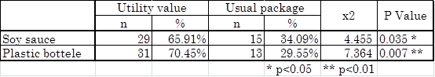

**H2. Aesthetic value of packaging affects Japanese consumer’s buying intention.**

H2 posits that aesthetic value of packaging affects Japanese consumer’s buying intention. Having collected the data, chi-square test was employed. Table 4 is a result of chi-square test. As shown in table 4, the results indicate that sense value of packaging has positive influence on Japanese consumer’s buying intention in this study. These results provide reasonable support for H2.

Table4. chi-square test for Hypotheses 2

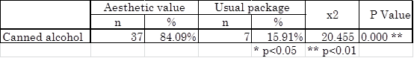

**H3. Utility value of packaging affects Chinese consumer’s buying intention.**

H3 posits that utility value of packaging affects Chinese consumer’s buying intention. Having collected the data, chi-square test was employed. Table 5 is a result of chi-square test. As shown in table 5, the results indicate that utility value of packaging has negative influence on Chinese consumer’s buying intention. Therefore, H3 is rejected.

Table5. chi-square test for Hypotheses 3

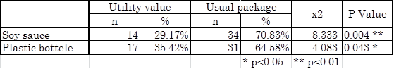

**H4. Aesthetic value of packaging affects Chinese consumer’s buying intention.**

H4 posits that aesthetic value of packaging affects Chinese consumer’s buying intention. Having collected the data, chi-square test was employed. Table 6 is a result of chi-square test. As shown in table 6, the results indicate that aesthetic value of packaging has negative influence on Chinese consumer’s buying intention. Therefore, H4 is rejected.

Table6. chi-square test for Hypotheses 4

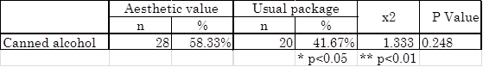

**H5: On utility value of packaging, there is difference between description and none description in Japanese consumer’s buying choice.**

H5 posits that on utility value of packaging, there is difference between description and none description in Japanese consumer’s buying choice. Having collected the data, independent t-test was employed. Table5 is a result of t-test. As shown in table, the results indicate that there were significant difference in soy sauce in effect of description on Japanese consumer’s buying choice in this study. But there were no significant difference in plastic bottle. These results reject for H5.

table7. independent t-test for hypothesis 5

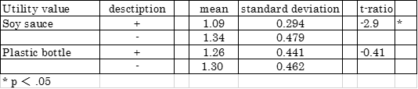

**H6: On aesthetic value of packaging, there is difference between description and none description in Japanese consumer’s buying choice.**

H6 posits that on aesthetic value of packaging, there is difference between description and none description in Japanese consumer’s buying choice. Having collected the data, independent t-test was employed. Table is a result of t-test. As shown in table, the results indicate that there were no significant difference in aesthetic value of packaging on Japanese consumer’s buying choice in this study. These results reject for H6.

table8. independent t-test for hypothesis 6



**H7: On utility value of packaging, there is difference between description and none description in Chinese consumer’s buying choice.**

H7 posits that on utility value of packaging, there is difference between description and none description in Chinese consumer’s buying choice. Having collected the data, independent t-test was employed. Table is a result of t-test. As shown in table, the results indicate that there were significant difference in soy sauce on Chinese consumer’s buying choice in this study. But, there were no significant difference in plastic bottle. These results provide reject for H7.

Table 9.independent t-test for hypothesis 7

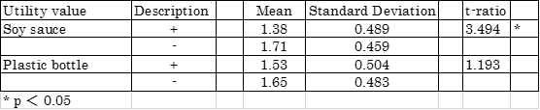

　From the result of open-ended question, we categorized six responses. The responses are reasonable price, easy to use, easy to dispose, good appearance, due to description, and others. The sample size of choosing usual soy sauce packaging due to description was 22. Among them, 17 (77%) responses were easy to use, 2 (9%) responses were easy to dispose, 14 (64%) responses were good appearance, and 2 (9%) responses were others. Further, the sample size of choosing soy sauce packaging added utility value due to description was 35. 1 (3%) response was reasonable price, 33 (94%) responses were easy to use, 2 (6%) responses were easy to dispose, 6 (17%) responses were good appearance, 4 (11%) responses were due to description, and 4 (11%) responses were others. On the other hand, the sample size of choosing usual soy sauce packaging due to none description was 35. 27 (77%) responses were easy to use, 1 (3%) response was easy to dispose, 27 (77%) responses were good appearance, and 3 (9%) responses were others. Further, the sample size of choosing soy sauce packaging added utility value due to none description was 15. 12 (80%) responses were easy to use, 6 (40%) responses were good appearance, and 9 (60%) responses were others.

Moreover, the sample size of choosing usual plastic bottle due to description was 30. 18 (60%) responses were easy to use, 5 (17%) responses were easy to dispose, 21 (70%) responses were good appearance, 1 (3%) response was due to description, and 3 (10%) responses were others. Further, the sample size of choosing plastic bottle added utility value due to description was 27. 13 (48%) responses were easy to use, 14 (52%) responses were easy to dispose, and 6 (22%) responses were good appearance. On the other hand, the sample size of choosing usual plastic bottle due to none description was 32. 23 (72%) responses were easy to use, 1 (3%) response was easy to disposal, and 22 (69%) responses were good appearance. Further, the sample size of choosing plastic bottle added utility value due to none description was 18. 10 (56%) responses were easy to use, 5 (28%) responses were easy to dispose, 7 (39%) responses were good appearance, and 7 (39%) responses were others.

**H8: On aesthetic value of packaging, there is no difference between description and none description in Chinese consumer’s buying choice.**

H8 posits that on aesthetic value of packaging, there is difference between description and none description in Chinese consumer’s buying choice. Having collected the data, independent t-test was employed. Table is a result of t-test. As shown in table, the results indicate that there were significant difference in sense value of packaging on Chinese consumer’s buying choice in this study. These results provide reasonable support for H8.

Table 10. independent t-test for hypothesis 8

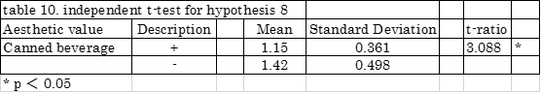

The sample size of choosing usual canned alcohol due to description was 10. 3 (30%) responses were easy to use, 9 (90 %) response was good appearance, and 1 (10%) response was others. Further, the sample size of choosing canned alcohol added aesthetic value due to description was 47. 4 (9%) responses were easy to use, 1 (2%) response was easy to dispose, 43 (91%) responses were good appearance, 10 (21%) responses were due to description, and 3 (6%) responses were others. On the other hand, the sample size of choosing usual canned alcohol due to none description was 19. 1 (5%) responses were easy to use, 17 (89%) response were good appearance, and 2 (11%) responses were others. Moreover, the sample size of choosing canned alcohol added aesthetic value due to none description was 31. 2 (6%) responses were easy to use, 25 (81%) responses were good appearance, and 4 (13%) responses were others.

**4.1 Findings from Experimental Investigation to Consumers**

In started above, these results of this study suggest that utility and aesthetic value of packaging improve Japanese consumer’s buying intention. However, in Chinese consumers, utility and aesthetic value of packaging can’t improve their buying intention.

In regard to effect of description, there were no effect in description on Japanese consumers. The reason why Japanese consumers didn’t improve their buying intention was that they had prior knowledge on products. On Chinese consumers, we couldn’t conclude that there were effect in description because these results differ from each product.

In other word, Although utility and aesthetic value of product packaging are valuable to Japanese consumers, they aren’t particularly valuable to Chinese consumers.

**4.2 Findings of Open-ended Question**

From the result of open-ended question, we found that there is no difference between description and none description.

**4.3 Group Interview**

To clarify why utility and aesthetic value of packaging didn’t affect Chinese consumers’ buying intention, and why there is no difference between description and none description in the result of open-ended question, we held a group interview (in total four groups) in the form of discussion to Chinese consumers. The number of Chinese consumers was 23, from five to six people per group. According to previous study, in spite of short time, group interview let consumer gain high level of experience productivity (Baker 1985). Thus we asked Chinese consumers in Japanese language school to clarify what element Chinese consumers desire product packaging and we asked where they get information about product.

**4.3.1 Result of Group Interview**

Twenty-one over twenty-three responses were luxurious and durable packaging is the most important element. Moreover, Chinese nationality is wary and distrustful compared to Japanese consumers.

**4.3.2 Findings of Group Interview**

The reason why Chinese consumers desired luxurious and durable on packaging was that many inferior quality goods appear in Chinese market. Therefore, we found that Chinese consumers didn’t desire added value like utility and aesthetic. Then, we found that Chinese consumers are wary and distrustful of indefinite information like word of mouth communication. Thus, we suspect that Japanese high quality packaging adding utility or aesthetic is not affect overseas consumers. Moreover, we suspect that Japanese firms selling convenience goods should adapt appeal points of packaging to every country.

**4.4 The secondary case study on local appropriative adaptation of product packaging across borders of 15 firms**

As mentioned in preceding section, we discovered that Chinese consumers mind excellent sophisticated feeling and durability of product packaging. Moreover, they tended to trust only information from reliable source of information when they purchase product. In other words, we expected that the point of product packaging that should appeal differ from between countries as with utility of packaging affects Japanese consumer’s buying intention, by contrast, luxurious and durable of packaging affects Chinese consumer’s buying intention. Thus, we did secondary case study with food, beverage and toiletry manufacture as selling convenience goods to know whether product packaging stimulates consumers’ buying behavior and how representation method of product packaging differ in foreign countries.

**4.4.1 Result of Investigation**

Table.11 Result of Investigation

|  |  |  |  |  |  |
| --- | --- | --- | --- | --- | --- |
|  | Firm's Name | industry | whether product packaging itself stimulates buying behavior | How to represent method of product packaging concretely | Reason |
| 1 | Koikeya | Food | There is fact. | How to use design, catch copy, sizzle, character, logo, and color which are all important. It gets different represent method of product packaging from Japan because there are different needs on targets and countries in some cases. | Because needs and target are different in consumers and countries. |
| 2 | Firm A | Food | It’s fact that there is a fan who notice funny catch copy. | For the same product packaging as Japan, a represent method of product packaging doesn't change basically. The only different point is introducing the height of Japanese quality to product packaging at foreign countries. | Because let consumers preserve what own products are. |
| 3 | Firm B | Food | There is fact. | Every country basically focuses on designability, color, sizzle and character. In Asia, character is used effectively. | There are a lot of immature people compared with Europe. Therefore, The character is easy to be accepted. |
| 4 | Firm C | Food | There is fact. | It makes sure that information can communicate consumers at in-store. Concretely, sizzle is used effectively. | Compared with Japan, product information isn't communicated right. |
| 5 | FirmD | Food | There is fact. | Compared with Japan, a POP is used effectively. | They deal in fermented soybeans at foreign countries. Therefore, A lot of consumers don’t recognize that. Thus,　it’s used as a means to let them recognize. |
| 6 | Mandom | Toiletry | There is fact. | The product packaging adapted to a taste of consumers in each country. For example, a catch copy is changed by countries and a POP is certainly put on the product at foreign countries. | The reason why we put POP is to inform consumers "What happen by using these products?" |
| 7 | Firm E | Toiletry | There is fact. | The important thing is how to appeal a product benefit to consumers. For example, POP and picture is effectively used and a word is mentioned clearly big. | Awareness of Bath salt in China is low. Therefore, there are a lot of consumers that they don't understand about product. Thus, it has to appeal a product benefit clearly. |
| 8 | ISEHAN | Toiletry | There is fact. | Japan’s appeal point of product packaging doesn't differ from foreign countries. The important thing of product packaging is character and clarity of product packaging. | There are two reasons to use character.  1)to attempt differentiation in product packaging  2)to appeal to young lady who becomes a target |
| 9 | Firm F | Toiletry | There is fact. | In China, we emphasize "made in Japan." or indication which  suggests Japan on packaging. | Because there is an absolute trust to Japan  products. |
| 10 | Firm G | Toiletry | There is fact. | How to use color, color scheme, word and clarity of specifications of the product which are all important. The different point compared with Japan is to emphasize in word “made in japan”. | Because when consumer in bad condition buys medicine, they are unwilling to read detail of sentence on packaging. |

**4.4.2 Findings from secondly firm interviews**

Based on our case study, we discovered valuable facts in this interviews.

1. The common fact that product packaging itself stimulates consumers buying behavior.

: All firms mentioned product packaging is effective to stimulate buying behavior.

2. Firms are changing a represent method of product packaging in foreign countries.

: Although the part that product packaging is changed every firm is various, 9 firms out of 10 firms change representation method of a product packaging in foreign countries.

3. Represent method of product packaging should be changed by selling phase and recognition of the product.

: Moreover, 5 firms out of 10 firms mentioned represent method of product packaging changes by selling phase and recognition of the product.

**4.5 The proposal of effective use of product packaging model**

In this chapter, we eventually propose the model for effective use of product packaging as the result of this study.

Based on empirical research, there are three valuable discovery in our study. Firstly, utility and aesthetic value of product packaging doesn’t affect Chinese consumer’s buying intention. Secondly, firms packaging strategy is that product packaging itself stimulates consumer’s buying behavior. Thirdly, Representation method of product packaging should be changed phase of market entry and recognition of the product.

In other words, product packaging can not only stimulate consumer’s buying behavior, but also stimulate more buying behavior by changing representation method of product packaging at the phase. Although we tried whether utility and aesthetic value of product packaging affects consumer behavior, but it was wrong way. Japanese firms selling convenience goods should classify representation method of product packaging by selling phase. Therefore, it is assumed that utility and aesthetic value of packaging are one of the options in this adaptation phase model.

Figure.3 Our adaptation phase model

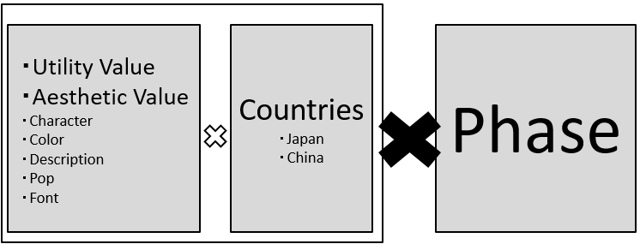

**5. Conclusion**

.

In this section we describe the outcome, limitation and expansion of our study.

In relation to objective one, this study can conclude that, in relation to the added value created by product packaging, there are two categories that specifically add value - utility and aesthetics. Other studies have failed to discover this feature of product packaging, and as such this study can contribute originally to research of product packaging and customer buying intention. Secondly, and in relation to the previous finding, this difference is also influenced by the nationality of the consumer. Added value of product packaging can affect Japanese consumer’s buying intention, while can’t affect Chinese consumer’s buying intention.

From this previous conclusion and in relation to objective two, this report can suggest the following model. First, this study discovered that Chinese consumers desire luxurious and durable packaging. This means that it is important for Japanese companies to adapt representation method of product packaging depending on selling phase and market of country, as such this study can contribute originally to research of product packaging strategy.

On limitations, our findings indicate that the representation method of product packaging is different by selling phase and market of countries. However, this study doesn’t clarify concretely about how product packaging should adapt representation method to selling phase. Second, this study focused on only convenience goods. Finally, we conducted an experiment survey to Chinese consumers. However, because of Chinese consumers living in Japan, Chinese consumers living in China are likely to be different from our study results.

Similarly, although this study focused on Chinese, many other countries are expected to be different from Chinese consumers.

**Acknowledgements**

We are deeply grateful to Prof. Tetsuya Usui who provided carefully considered feedback and valuable comments. Also, we would like to express our gratitude to Ryan HARTLEY who provided technical help and sincere encouragement. Special thanks also go to Prof.Noguchi.Moreover, we would like to thank the firms and great cooperation of those who answer our consumer questionnaires that made it possible to complete our study. Without enormous contribution of the firms and cooperation of those who answer our consumer questionnaires, this study would not have been possible.

Finally we are very grateful to classmates of Usui seminar for their valuable cooperation and in-depth discussion.

**Selected References**

Butkeviciene, V., J. Stravinskiene and A. Rutelione (2008). 'Impact of consumer package communication on consumer decision making process', Inzinerine Ekonomika-Engineering Economics(1), p. 57-65.

Connolly, A, and Davidson, L. (1996), “How Does Design Affect Decisions at Point of Sale?”, Journal of Brand Management, Vol 4 No2, pp. 100-107.

Don E Schultz (1993), “Integrated Marketing Communications:Putting it Together & Making It Work. McGraw-Hill; 1 edition (January 11,1993)

Jan P. L. and Henry S. J. Robben (1997) “The Effect of New Package Designing on Product Attention, Categorization and Evaluation,” Journal of Economic Psychology, Vol.18, No.4, pp.271-287.

Keller, K. L. (2010) “Strategic Brand Management Third Edition”, Prentice Hall (恩蔵直人訳『戦略的ブランド・マネジメント 第3 版』, 東急エージェンシー部, 2010)

Kotler, Philip (2003),‘Marketing Management (11thed.),’ Prentice-Hall.

Kupiec and Revell (2001), "Measuring consumer quality judgements", British Food Journal, Vol. 103 Iss: 1, pp.7 - 22

Olga Ampuero Natalia Vila (2006) “Consumer perceptions of product

packaging,” Journal of Consumer Marketing, Vol.23 lss2, pp.100-112

Pinya Silayoi, Mark Speece, (2004) "Packaging and purchase decisions: An exploratory study on the impact of involvement level and time pressure", British Food Journal, Vol. 106 Iss: 8, pp.607 – 62

Pinya Silayoi, Mark Speece, (2007) "The importance of packaging attributes: a conjoint analysis approach", European Journal of Marketing, Vol. 41, pp.1495 – 1517

POPAI（1996）“POPAI Study: In-store Decisions Rule,” Discount

Merchandiser, Vol.36,No.3, pp.19

Robert L. Underwood, Noreen M. Klein, and Raymond R. Burke (2001) “Packaging Communication: attentional effects of product imagery,” Journal of Product & Brand Management, Vol.10, No. 7, pp.403-422.

Robert K. Yin, (2009) “Case Study Research:Design and Methods Fourth Edition”, SAGE Publications, Inc.

Ruth Rettie and Carol Brewer (2000) “The Verbal and Visual Components of Package Design” Journal of Product and Brand Management, Vol. 9, No.1, pp.56-70.Schoormans,

Stern（1985）“The Significance of Impuluse Buying Today,” Journal of　Marketing, Vol.26, No.2

Ulrich R. Orth, Keven Malkewitz (2008) Holistic Package Design and Consumer Brand Impressions. Journal of Marketing: Vol. 72, No. 3, pp. 64-81.

Underwood, Robert L. (2003),“The Communicative Power of Product Packaging : Creating Brand Identity via Lived and Mediated Experience,”Journal of Marketing Theory and Practice,Winter, pp.62-76.

■和文献

青木幸弘他（2012）『消費者行動論　マーケティングとブランド構築への応用』　有斐閣アルマ

青木幸弘他（2011）『価値共創時代のブランド戦略―脱コモディティ化への挑戦―』ミネルヴァ書房

青木幸弘（2010）『消費者行動論の知識』日経文庫

阿部界（2009）『パッケージデザインマネジメント戦略　2009』株式会社富士経済

池尾恭一（他）(2010)『日本型マーケティングの新展開』有斐閣

石井淳蔵他（2013）『ゼミナールマーケティング入門　第2版』日本経済新聞出版社

石井祐明（2009）「パッケージデザインと消費者反応―制御焦点理論によるシンメトリー性に関する考察」『商学研究科紀要』第69巻。219-231頁。

石井祐明（2012）「店頭でのマーケティング展開と消費者行動」『CUC view & vision』、第33巻。23-29頁。

石井祐明他（2007）「パッケージにおける言語的情報と非言語的情報の配置の効果」『商品開発管理研究』第4巻、第１号

稲垣佳伸（2003）「9割は店頭で決まる―事実観察から仮説を導け―」『日経食品マーケット』7月号。130-131頁。

大風かおる（2011）「製品パッケージのコミュニケーション効果」『マーケティングジャーナル』第30巻、第4号。108-117頁。

小川亮（2010）『図解でわかるパッケージデザインマーケティング』日本能率協会マネジメントセンター

小川長(2011)『コモディティ化と経営戦略』尾道大学経済情報論集　第11巻1号177-209貢

恩蔵直人他（2002）『ブランド要素の戦略論理』早稲田大学出版部

恩蔵直人（2007）『コモディティ化市場のマーケティング論理』有斐閣

金子修也（1989）『パッケージ・デザイン　夜も地球も パッケージ』 鹿島出版会

酒井隆（2003）『図解 アンケート調査と統計解析がわかる本』日本能率協会マネジメントセンター

外川拓（2010）「消費者反応に及ぼすパッケージ要素の効果―既存研究の整理と課題―」『商学研究科紀要』第71号。201-214頁。

外川拓（2010）「パッケージデザインに対する知覚と評価―広告研究に基づく余白の効果に関する検討―」『商学研究科紀要』第74号。77-89頁。

長崎秀俊（2003）「コ・ブランディングによるパッケージ効果の研究―サントリーのアド生を用いた実験調査―」『グノーシス　法政大学産業情報センター紀要』第12号。33-55頁。

西川英彦（2012）『1からの商品企画』碩学舎

日経デザイン包装向上委員会編（2007）『売れるパッケージデザインの秘密50』日経BP社

延岡健太郎（2002）『製品開発の知識』日本経済新聞社

橋田洋一郎（2011）「ボトムアップ型注意を考慮に入れたパッケージデザインの評価」『情報科学研究』第31号。43-58頁。

平久保仲人（2005）『消費者行動論―なぜ、消費者はAではなくBを選ぶのか？―』ダイヤモンド社

宮本文幸（2014）『商品パッケージの消費者効果-化粧品における新カテゴリー創造の手法「感性記憶型パッケージング」の実証研究』静岡学術出版

ラリーパーシー（1999年）『実践・IMC戦略』日経広告研究所

渡部千春（2010）『日本ブランドが世界を巡る』日経BP社

和田充夫 (2002)『ブランド価値共創』同文舘出版

■雑誌・WEBデータ

Choice for the Future May 2014 Committee for Japan’s Future. Cabinet Office (2015年10月21日アクセス)<http://www5.cao.go.jp/keizai-shimon/kaigi/special/future/chuukanseiri/04_e.pdf>

2014 Survey of Overseas Business Activities. Ministry of Economy ,Trade and Industry <http://www.meti.go.jp/english/statistics/>(2015年10月21日アクセス)

「キッコーマンHP」http://www.kikkoman.co.jp/index.html （2015年7月6日アクセス）

「キリンHP」<http://www.kirin.co.jp/>　（2015年7月6日アクセス）

「公益社団法人 日本包装技術協HP」　http://www.jpi.or.jp/saiji/jpc/2012/001.html　（2015年7月6日アクセス）

「コカ・コーラHP」　<http://www.cocacola.co.jp/brands/all-products/（2015年７月６日アクセス）>

「資生堂HP」　https://www.shiseido.co.jp/tsubaki/　（2015年７月６日アクセス）

「しょうゆ便瓶は『黒』のイメージを変え、『白』で女性の支持を獲得」http://www.nikkeibp.co.jp/article/column/20120217/299524/rt=nocnt （2015年5月30日アクセス）

「宣伝会議　分かりやすい、美味しそう、棚で目立つ」http://mag.sendenkaigi.com/hansoku/201508/promotion-pkg/005794.phf（2015年9月2日アクセス）

「東洋経済オンライン　キッコーマン『生しょうゆ』、3つの革命―1500社がひしめく激戦区でスマッシュヒット」http://toyokeizai.net/articles/-/12321（2015年9月1日アクセス）

トムソン・ロイター「IPマーケットリポート」で食品包装市場の動向を分析

<http://ip-science.thomsonreuters.jp/press/release/2011/426522/>　（2015/6/30閲覧）

「日経Bizアカデミー『グローバルマーケティング講座』」http://bizacademy.nikkei.co.jp/special/gmk2012/lesson2.html（2015年9月2日アクセス）

「ミツカンHP」　<http://www.mizkan.co.jp/index.html>　（2015年７月６日アクセス）

|  |  |
| --- | --- |
|  | 学校名（敬称略） |
| １ | 大原日本語学院 |
| ２ | アークアカデミー新宿学校 |
| ３ | 東京日本語外語学院 |
| ４ | 日本大学 |
| ５ | YMCA東京日本語学校 |

Accompanying material 1.

Accompanying material 2.

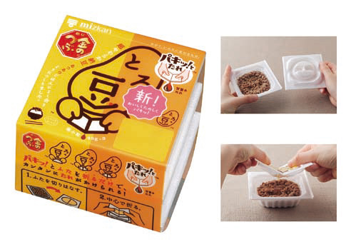

（出典：ミツカン公式ホームページ）

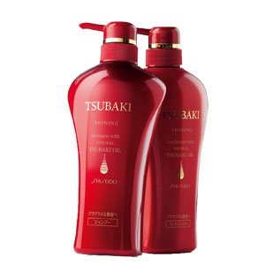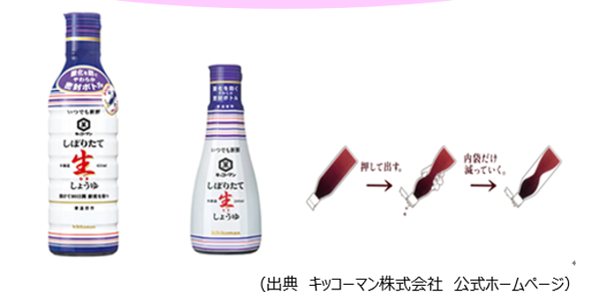

（出典：資生堂公式ホームページ）　　　　　（出典：キッコーマン公式ホームページ）

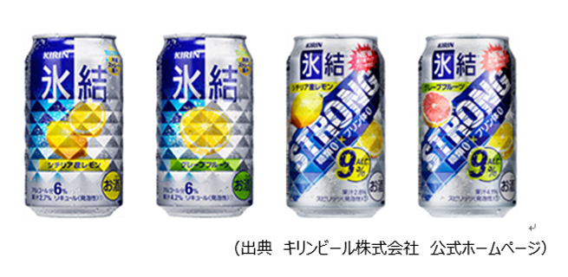

（出典：KIRIN公式ホームページ）

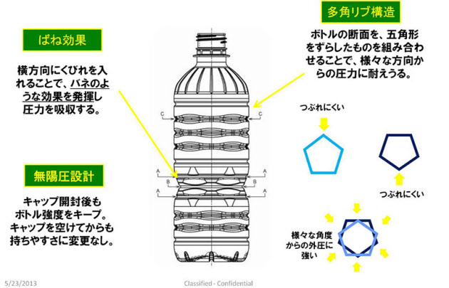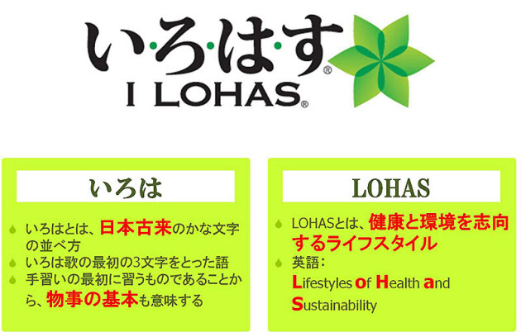

（出典：コカコーラ公式ホームページ）

Accompanying material 3.Question Sheet

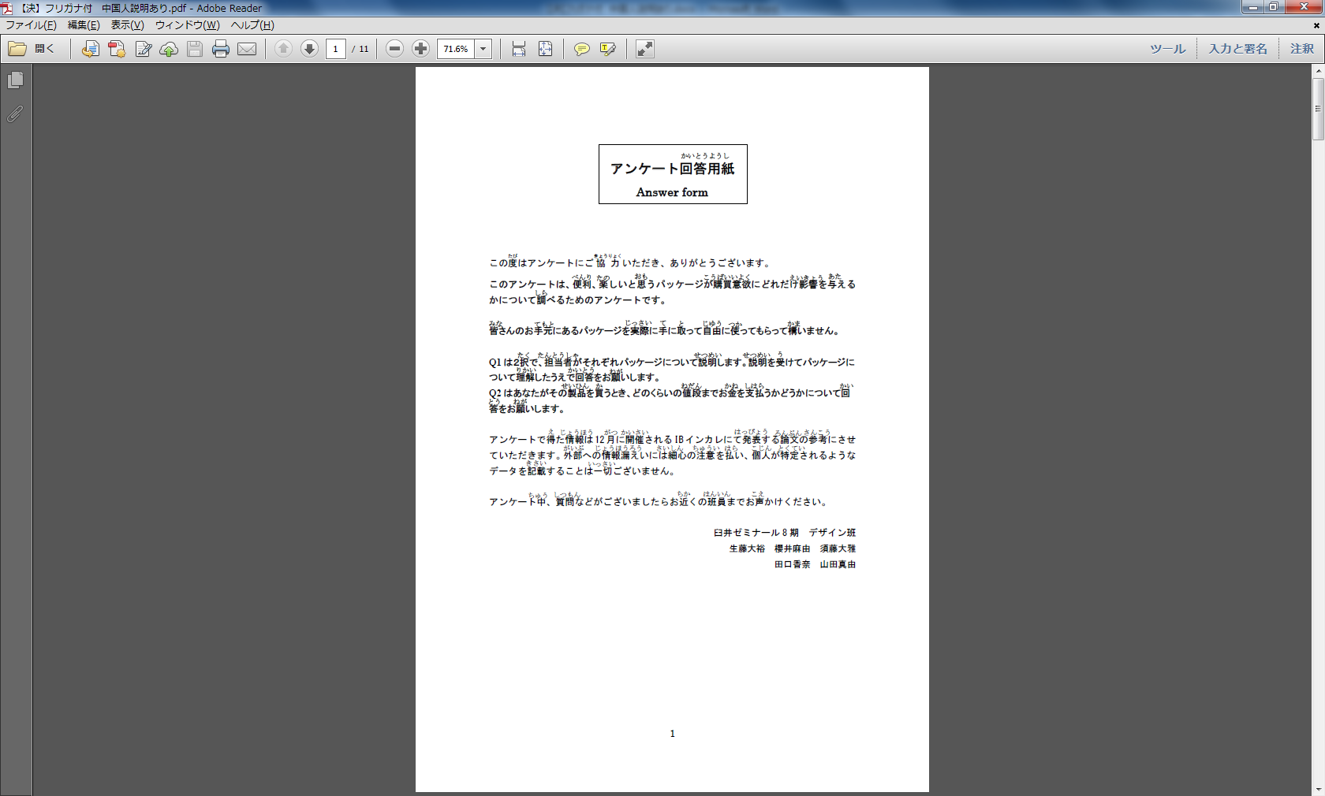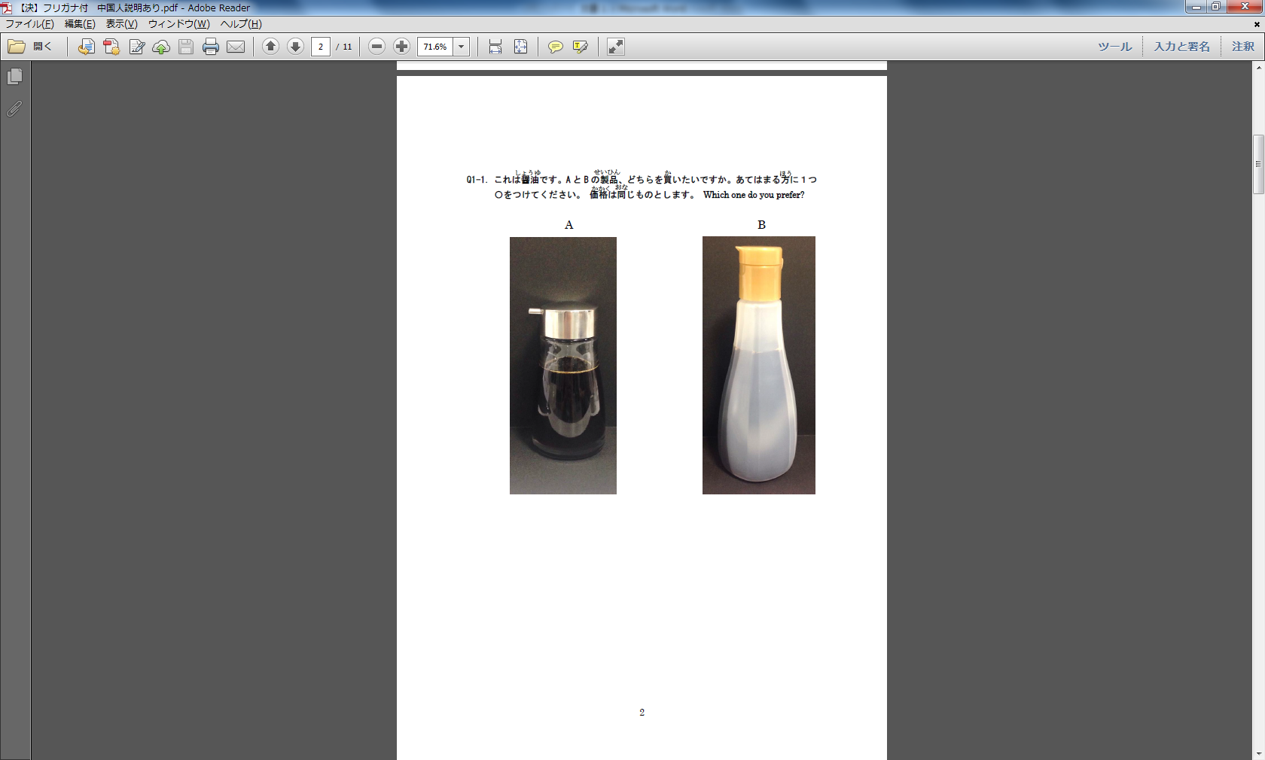

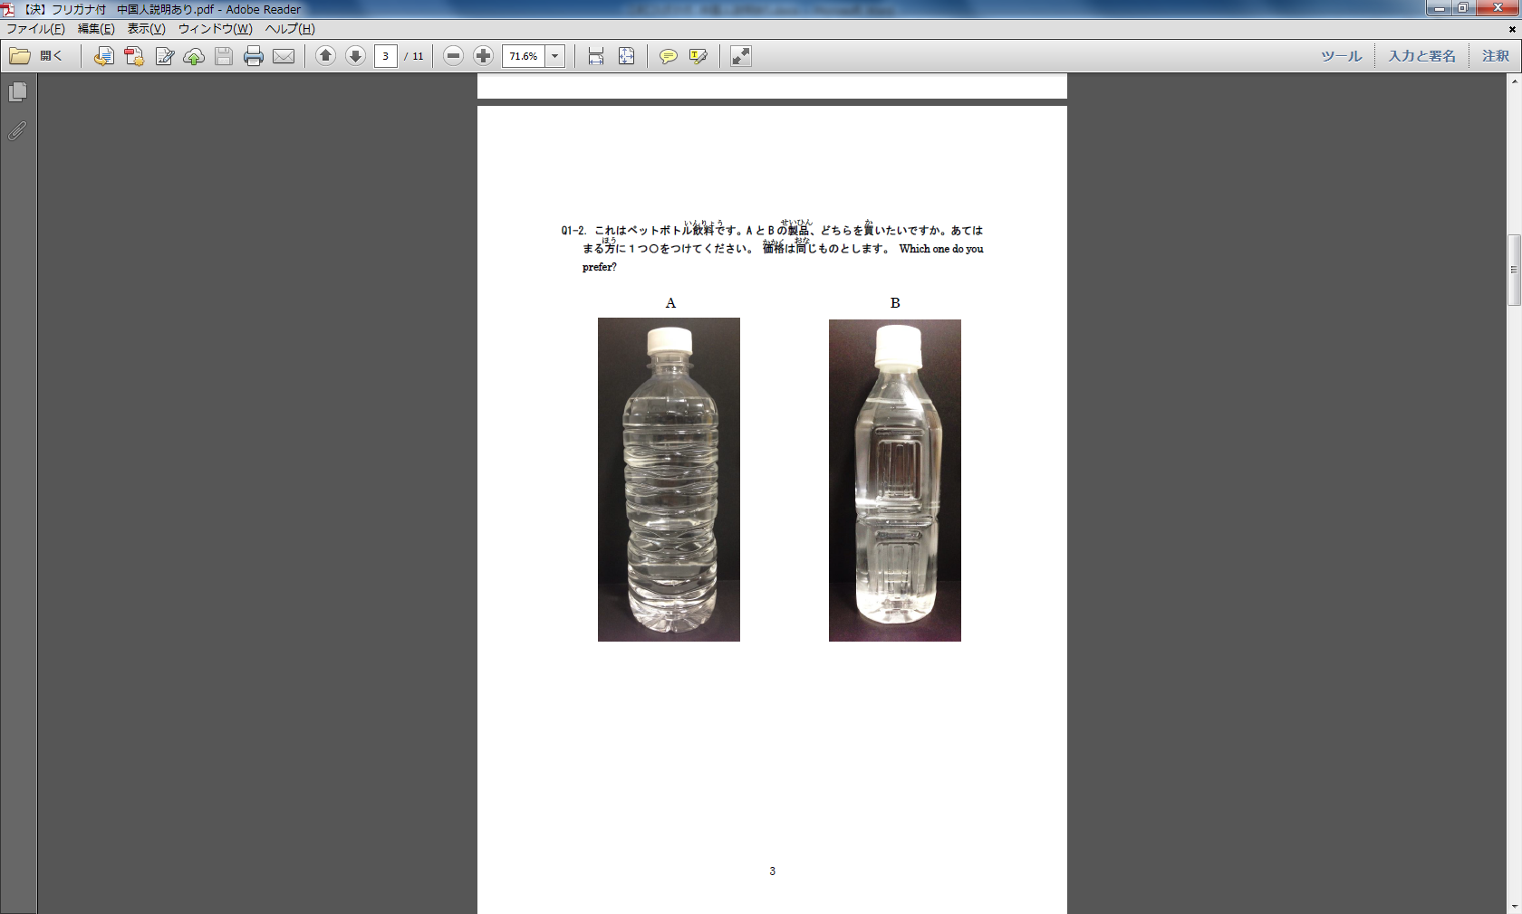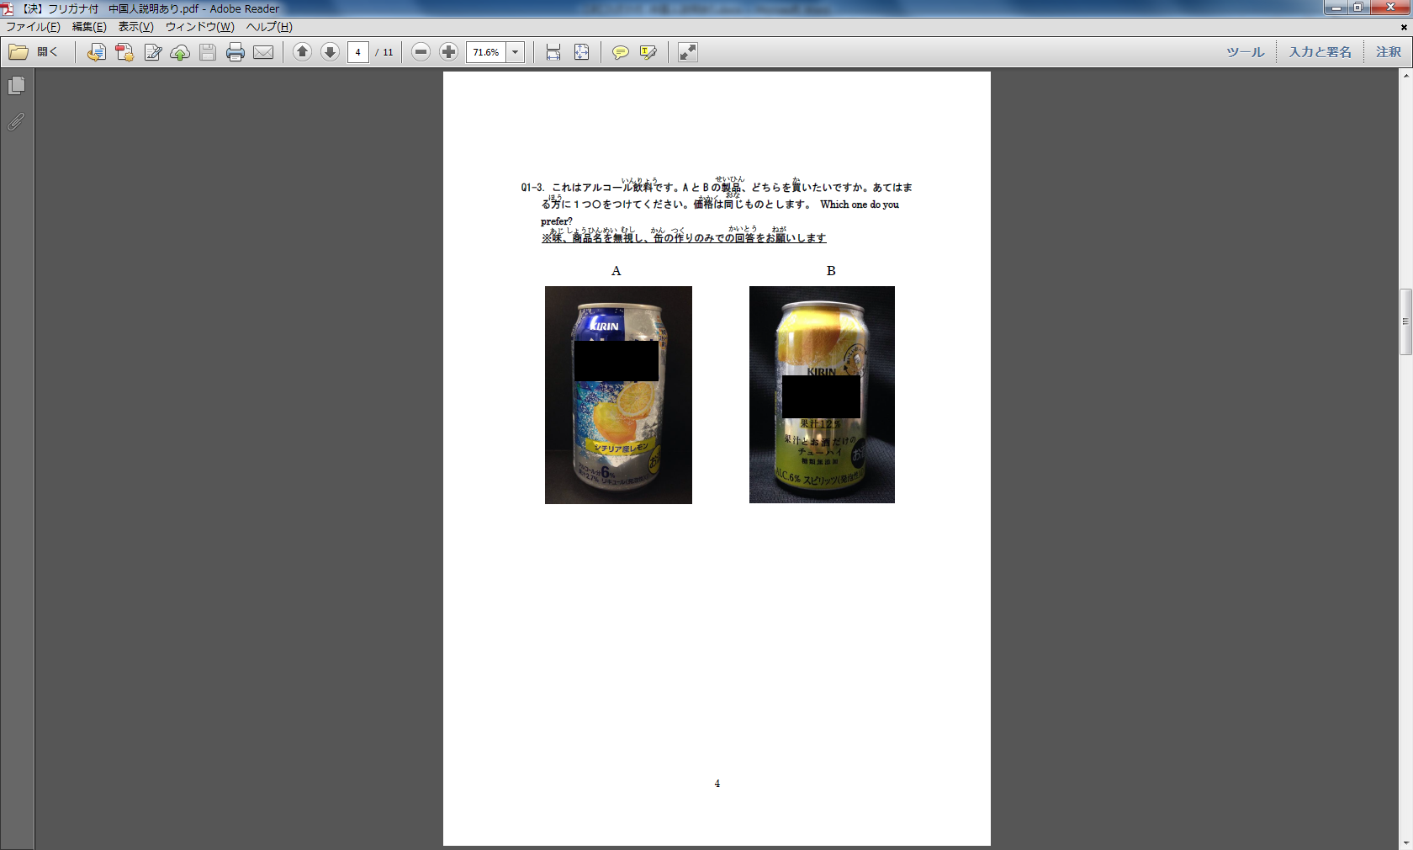

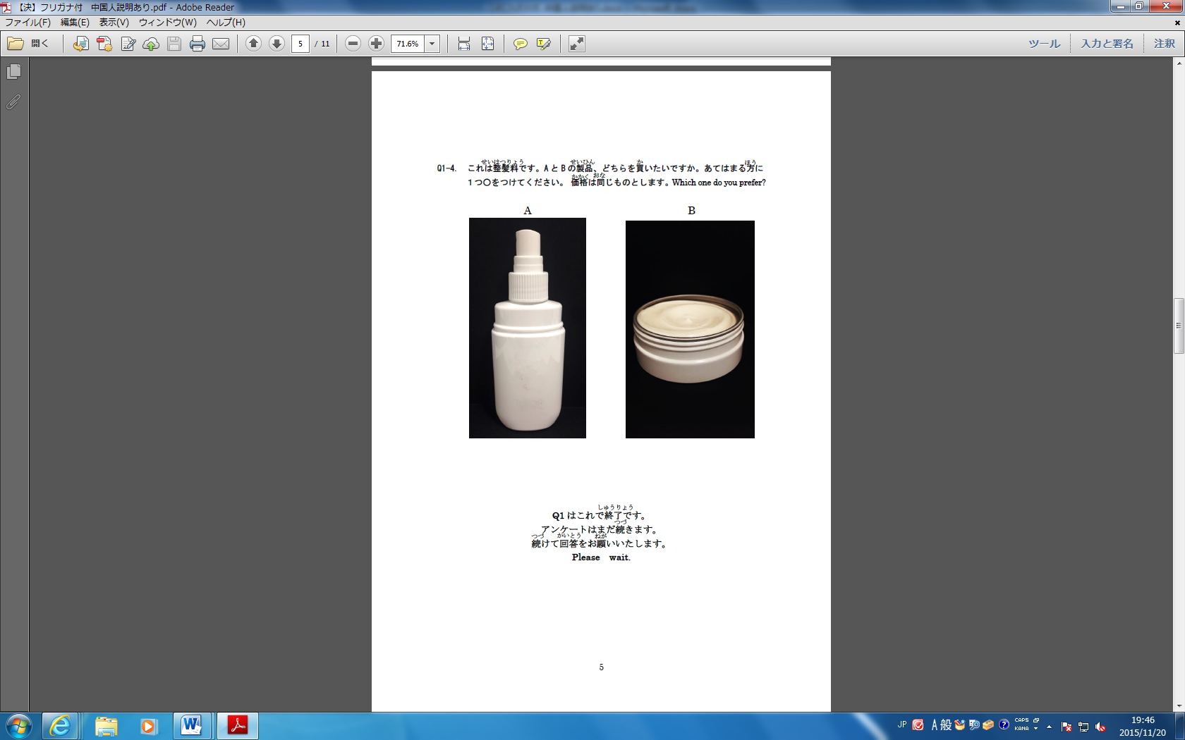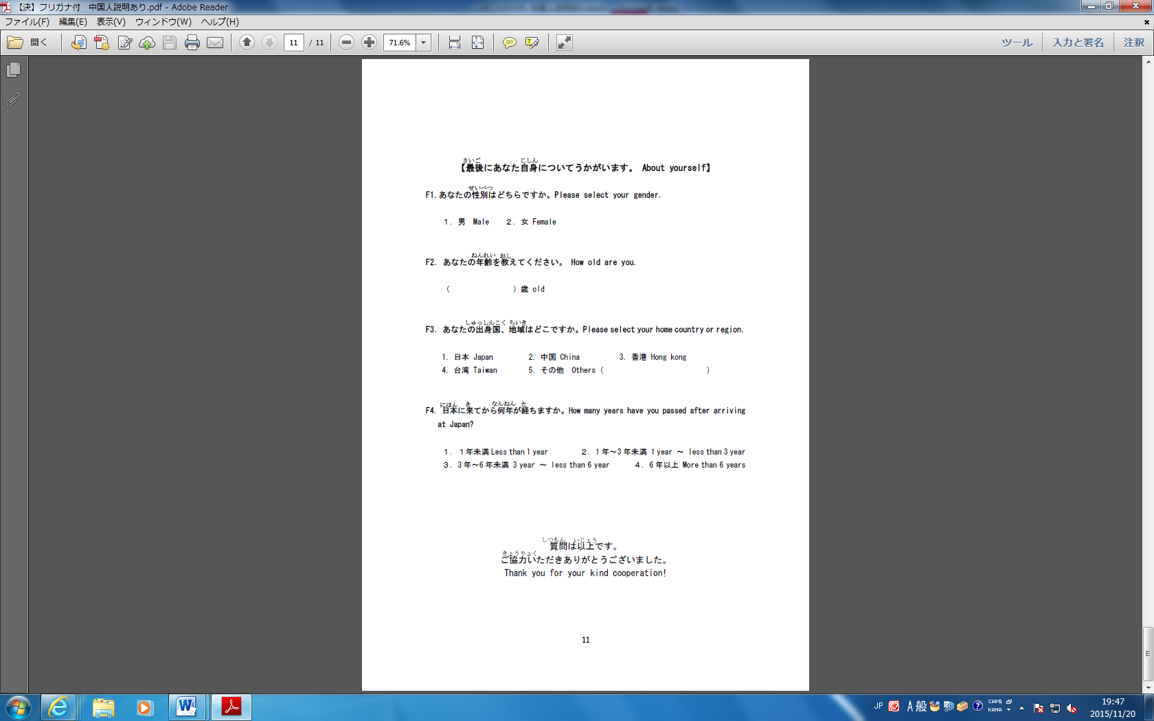

Accompanying material 4

As stated above we conducted consumer experiment using packaging samples. Actually, we also used “UNO FOG BAR”, and usual hair dressing packaging. However, we exclude “UNO FOG BAR” and usual hair dressing packaging in this thesis because it is assumed that main purpose of consumer purchasing these products is content.

chi-square test for Hypotheses 1



chi-square test for Hypotheses 2





